**Making of azure Virtual machine with 16 gb ram and 4 vcpu**

**az vm create \**

**--resource-group YuvrajRgDocker \**

**--name Yuvrajvm \**

**--image Ubuntu2204 \**

**--admin-username azureuser \**

**--size Standard_D4s_v3 \**

**--vnet-name MyVNet \**

**--subnet MySubnet \**

**--public-ip-address-dns-name myuniquepublicdnsname \**

**--authentication-type ssh \**

**--ssh-key-value @~/.ssh/id_rsa.pub**

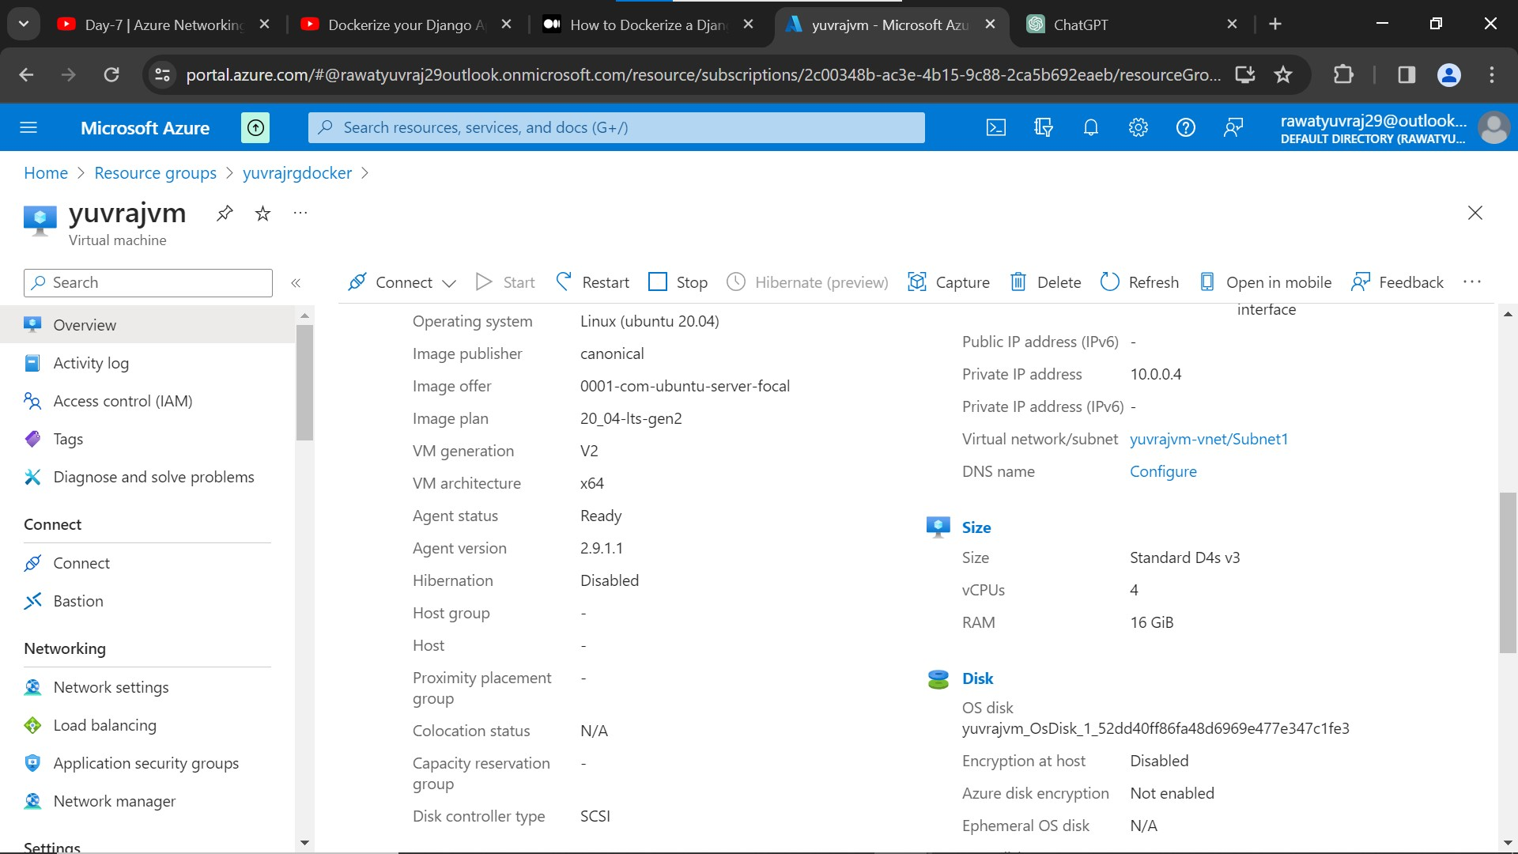

–sample django project

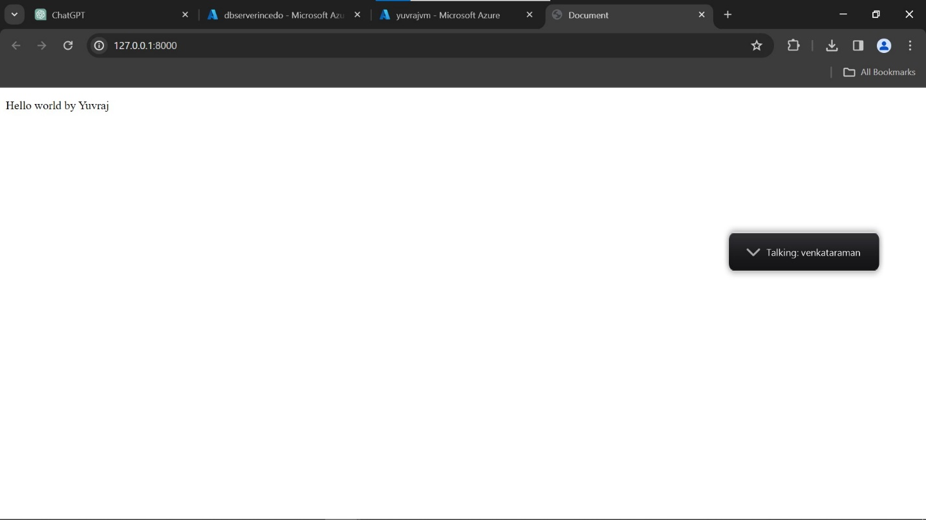

**– connecting to virtual machine using ssh**

**ssh -i C:\Users\yuvraj.rawat1\Downloads\yuvrajvm_key3.pem azureuser@172.203.165.170**

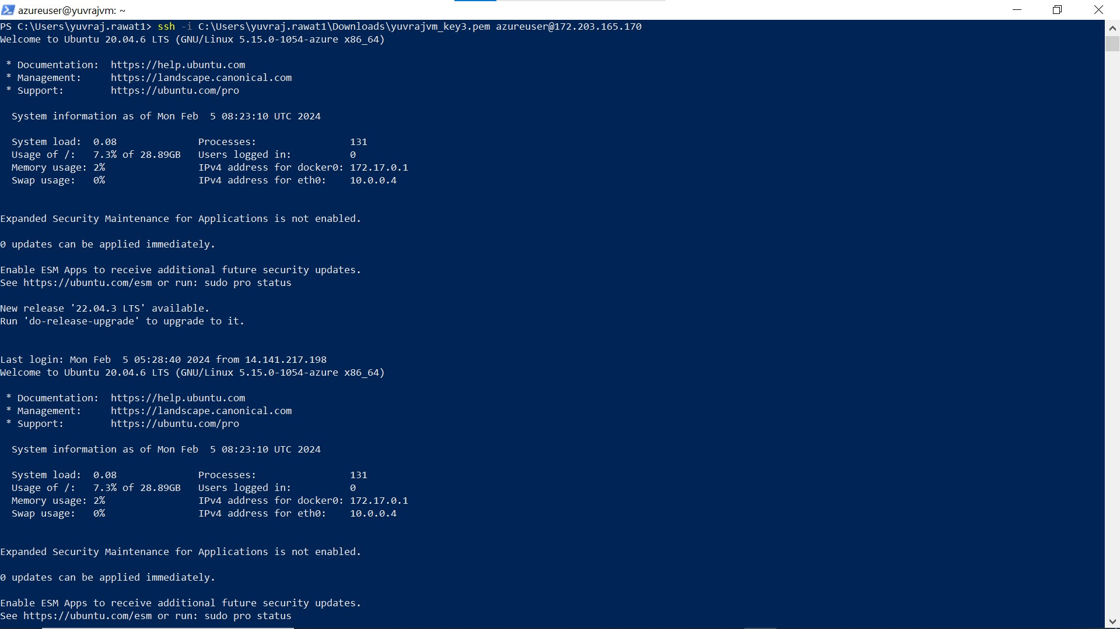

**–Installing docker on virtual machine**

**sudo apt-get update**

**sudo apt-get install apt-transport-https ca-certificates curl software-properties-common**

**curl -fsSL https://download.docker.com/linux/ubuntu/gpg | sudo apt-key add -**

**sudo apt-key fingerprint 0EBFCD88**

**sudo add-apt-repository "deb [arch=amd64] https://download.docker.com/linux/ubuntu $(lsb_release -cs) stable"**

**sudo apt-get update**

**sudo apt-get install docker-ce docker-ce-cli containerd.io**

**sudo usermod -aG docker $USER**

**sudo docker run hello-world**

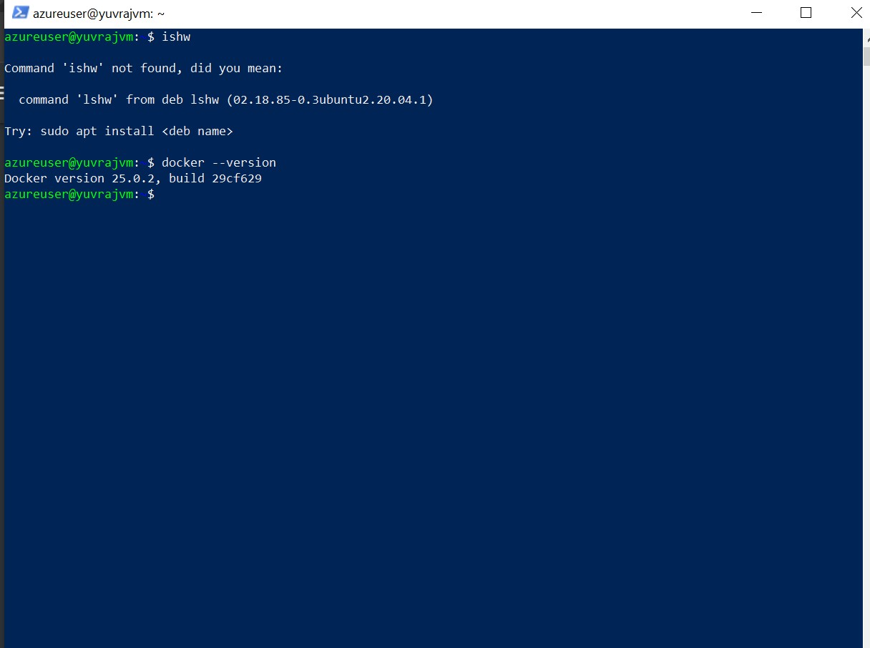

**– creating django image and containerizing it**

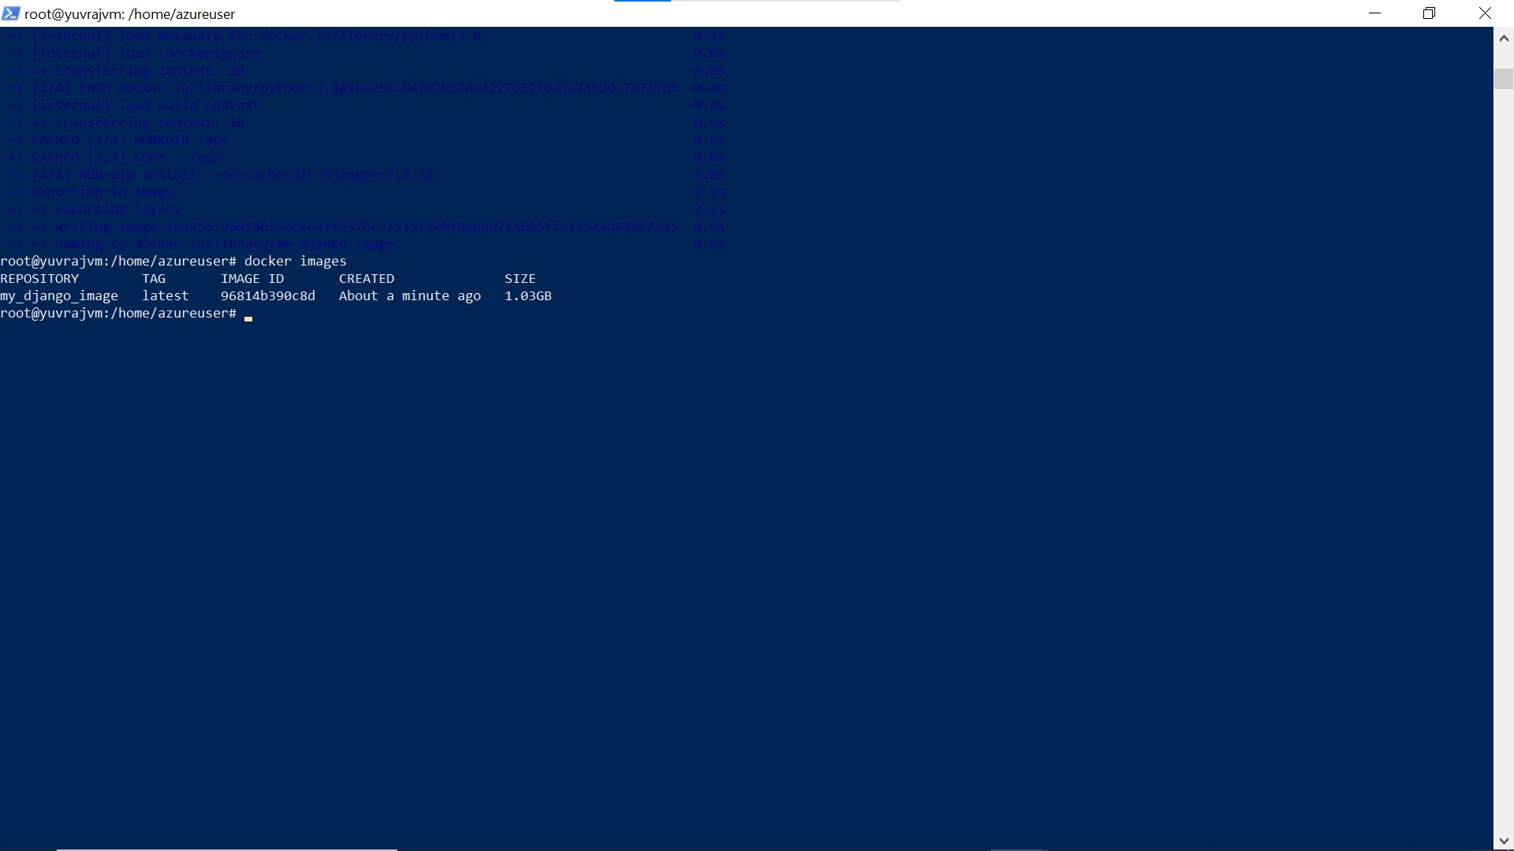

**– Docker project using Docker play**

